9.60: For this case, 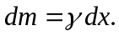
a) 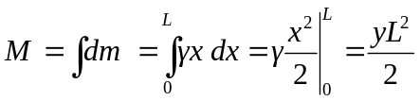
b) 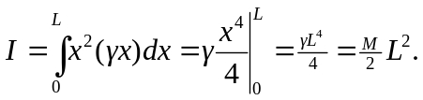
This is larger than the moment of inertia of a uniform rod of the same mass and length, since the mass density is greater further away from the axis than nearer the axis.
c) 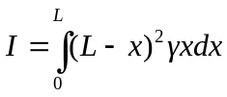
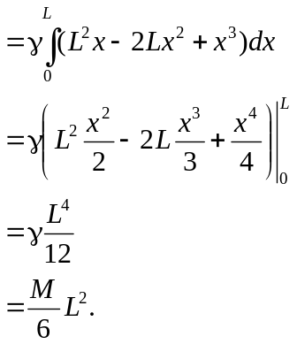

This is a third of the result of part (b), reflecting the fact that more of the mass is concentrated at the right end.

